
Assignment command words
Understand what the objective wants you to do!
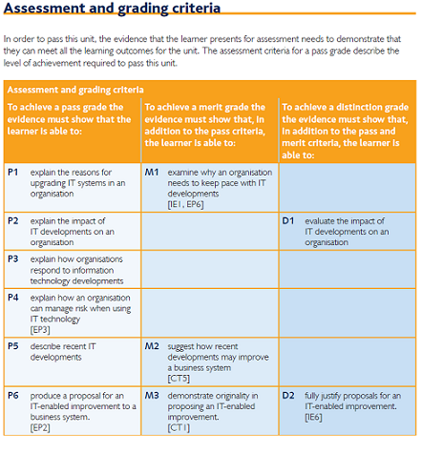
Look at the command words for the unit – work out what they want you to do!!!

Command word | What it means
Compare | Write about the differences and similarities.
Demonstrate | Give the proof of something, usually by practical example.
Describe | Say what something or someone is like or give an account of events.
Discuss | Explain the advantages and disadvantages of something, and give your opinion.
Evaluate | Make a judgement about the quality of something, taking the evidence into account.
Examine | Look into something methodically in order to find out the facts.
Explain | Give reason WHY something is as it is or HOW it operates.
Illustrate | Clarify something by use of examples or comparisons.
Identify | Point out the required features or reasons.
Justify | Give good reasons for.
Recommend | Explain how something would be good or suitable for a particular job or purpose.
Review | Examine something and make a critical discussion based on the facts.

